http://www.sciencedaily.com/releases/2008/10/081027174640.htm

Wildflower Declines In Thoreau's Concord Woods Are Due To Climate Changes

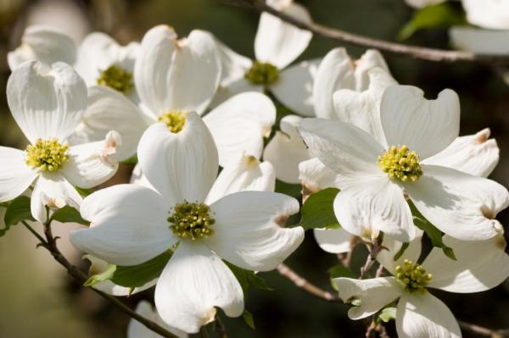

Dogwood flowers. Plant families that have been especially hard-hit by global warming have included lilies, orchids, buttercups, violets, roses, dogwoods, and mints. (Credit: iStockphoto/Melissa Carroll)

ScienceDaily (Nov. 1, 2008) — Drawing on records dating back to the journals of Henry David Thoreau, scientists at Harvard University have found that different plant families near Walden Pond have borne the effects of climate change in strikingly different ways. Some of the plant families hit hardest by global warming have included beloved species like lilies, orchids, violets, roses, and dogwoods.

Over the past 150 years, some of the plants in Thoreau's woods have shifted their flowering time by as much as three weeks as spring temperatures have risen, the researchers say, while others have been less flexible. Many plant families that have proven unable to adjust their flowering time have experienced sharp declines or even elimination from the local landscape -- the fate of nearly two-thirds of the plants Thoreau found in the 1850s around Walden Pond in Concord, Mass.

"It had been thought that climate change would result in uniform shifts across plant species, but our work shows that plant species do not respond to climate change uniformly or randomly," says Charles C. Davis, assistant professor of organismic and evolutionary biology in Harvard's Faculty of Arts and Sciences. "Some plants around Walden Pond have been quite resilient in the face of climate change, while others have fared far worse. Closely related species that are not able to adjust their flowering times in the face of rising temperatures are decreasing in abundance."

Some 27 percent of all species Thoreau recorded in the mid-19th century are now locally extinct, and another 36 percent are so sparse that extinction may be imminent. Plant families that have been especially hard-hit by global warming have included lilies, orchids, buttercups, violets, roses, dogwoods, and mints. Many of the gainers have been weedier mustards and knotweeds, along with various non-native species.

"The species harmed by climate change are among the most charismatic found in the New England landscape," Davis says. Scientists can be reasonably confident these losses have resulted from climate change and not habitat loss, he adds, since 60 percent of the land in Concord has remained protected or undeveloped since Thoreau's observations of the area between 1851 and 1858.

Understanding the decline of species abundance over time is constrained by the limited availability of historic data. Davis' work with Harvard graduate students Charles Willis and Brad Ruhfel combines contemporary data, collected by scientists Richard Primack and Abraham Miller-Rushing at Boston University, with Thoreau's records from his time spent at Walden Pond. Thoreau kept meticulous notes documenting the natural history of the region, plant species occurrences, and flowering times. Since then, botanists have resurveyed the territory to create a unique, community-level perspective covering 150 years. During this period, the mean annual temperature in the Concord area has increased by 2.4 degrees Celsius, or 4.3 degrees Fahrenheit.

"The plants in our survey now flower, on average, one week earlier in the spring than their ancestors did in Thoreau's time," Davis says. "However, there is wide variation among plant families. Some have shown no shift in flowering at all, while others now bloom 16 to 20 days earlier in the spring."

As mean annual temperatures increase, plants can adjust their growth patterns in several ways. For example, forests shift toward the poles, alpine tree lines move up mountains to higher altitudes, and flowering time can shift. During eras of climate change, plants that cannot adjust their flowering schedule -- and thus flower at sub-optimal times -- may experience dramatic declines in population size and local extinction.

The work appears this week in the Proceedings of the National Academy of Sciences.

Davis' co-authors are Harvard graduate students Charles Willis and Brad Ruhfel and Richard Primack and Abraham Miller-Rushing of Boston University. Their work was supported by the National Science Foundation.

--------------------------------------------------------------------------------

Adapted from materials provided by Harvard University, via EurekAlert!, a service of AAAS.
Need to cite this story in your essay, paper, or report? Use one of the following formats:
APA

MLA Harvard University (2008, November 1). Wildflower Declines In Thoreau's Concord Woods Are Due To Climate Changes. ScienceDaily. Retrieved November 5, 2008, from http://www.sciencedaily.com /releases/2008/10/081027174640.htm

